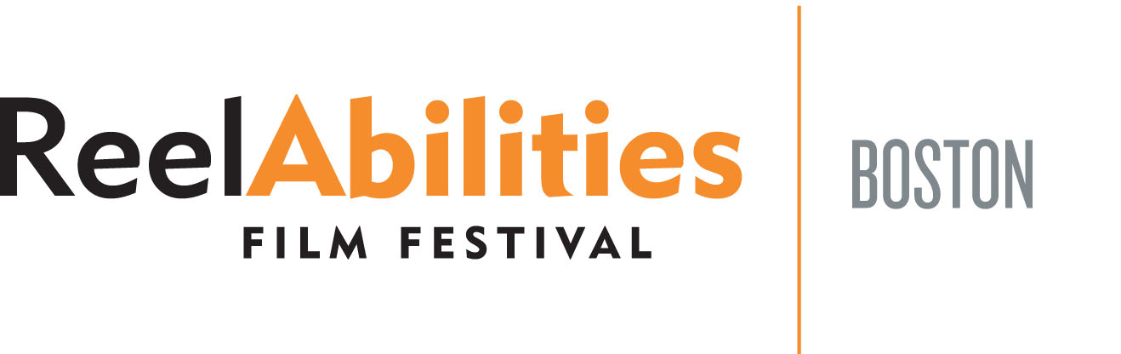
Media Contact:
Erin Callanan
erin@callananklein.com
617-905-6866

2017 ReelAbilities Film Festival Celebrates Determination and Unique Perspectives

Official Selections Announced; Tickets On Sale Now for
March 29-April 6, 2017 Festival

Newton, MA March 2, 2017 -- The Sixth Annual ReelAbilities Film Festival, Boston has announced the official selections for this year’s festival. Ten films have been selected and will be screened between March 29-April 6, 2017.

ReelAbilities strives for the inclusion of all people and is dedicated to promoting awareness and appreciation of the lives, stories and artistic expressions of people with different abilities from a variety of communities.

“The line-up for this year’s ReelAbilities Film Festival is one of the best we’ve ever had in Boston due to the number of high quality documentary films produced about people with disabilities,” said Mara Bresnahan, Festival Director. “Each documentary challenges our audience to think differently about people with disabilities in a time when conversations about diversity are crucial. In addition to the variety of perspectives represented in the films, their stories unfold on the screen in a unique and beautiful way.”

The films selected for the 2017 Festival include:

- Life, Animated – Directed by Roger Ross Williams, Life, Animated is an Oscar-nominated documentary that introduces us to Own Suskind, a young man with autism who, as a child, was unable to speak until he and his family discovered a unique way to communicate – immersing themselves in the world of classic Disney animated films. Ron Suskind, Owen’s father and author of the New York Times bestseller that inspired the film, will lead a discussion on how these stories helped his family find their way through hard times.

- The Rebound – Directed by Shaina Allen, The Rebound follows the underdog journey of the Miami Heat Wheels wheelchair basketball team in their quest for a national championship. The screening will be followed by a discussion with members of the Boston Blazers, a local wheelchair basketball team.

- Asperger’s Are Us – Co-presented with the Bright Light Series, Asperger’s Are Us is a documentary about the first comedy troupe consisting of openly autistic people. The film follows four friends from the North Shore of Boston as they prepare for their final, ambitious comedy show before going their separate way. A discussion will follow with director Alex Lehmann and members of the comedy troupe.

- True Smile – Directed by Juan Rayos, True Smile is an astonishing journey as seen through the eyes of 26-year-old Sergio Aznárez Rosado, who was born both blind and with autism, yet lives a life packed with adventure. Over the course of 30 days, Sergio embarks on a 1,300-kilometer tandem bike ride across Spain and Morocco with his brother, Juan Manuel, who pilots the bicycle. This screening is co-presented with Waypoint Adventure.

- That Which is Possible – Directed by Michael Gitlin, That Which is Possible follows a community of painters, sculptors, musicians, and writers who create art at the Living Museum, an art space on the grounds of a large state-run psychiatric facility in Queens, NY. A discussion with artists from Gateway Arts will follow the screening.

- My Hero Brother – Directed by Yonatan Nir, My Hero Brother follows a group of young Israelis with Down syndrome and their siblings as they embark on a demanding trip through the Indian Himalayas, where the conflicts and the complexities of their relationships come to the surface. My Hero Brother is co-presented with The Boston Jewish Film Festival.

- Notes on Blindness – In 1983, after many decades of deterioration, writer and theologian John Hull became totally blind. To help him make sense of the upheaval in his life, he documented his experiences on audio cassette and in this film, actors lip-sync to the voices, resulting in a poetic and intimate story. A Skype Q&A with directors James Spinney and Peter Middleton will follow the screening. This screening is co-presented with The DocYard.

- Rachel Is – Directed by Charlotte Glynn, Rachel Is explores the relationship between Jane and Rachel, her daughter with a developmental disability as each seeks independence from the other. A discussion will follow with Ms. Glynn, along with Susan Senator, author of Autism Adulthood: Strategies and Insights for a Fulfilling Life.

- Gabe – Gabe Weil is a 27-year-old who was born with the most severe form of muscular dystrophy who was told he would be lucky to live past 25. The news that he was misdiagnosed, and might live well into his 50s, forces him to rethink his life from scratch. Following the screening, a discussion will be held with director Luke Terrell.

- Marathon: The Patriots Day Bombing – Directed by Annie Sundberg and Ricki Stern, this gripping documentary focuses on the emotional and physical recovery of the individuals whose lives were forever changed by the Boston Marathon bombing. Discussion to follow with film subjects Patrick Downes and Jessica Kensky, moderated by Boston Globe reporter Eric Moskowitz. This screening is co-presented with GlobeDocs and Spaulding Rehabilitation Network.

The 2017 ReelAbilities Film Festival Boston is co-presented by The Boston Jewish Film Festival and sponsored by the Ruderman Family Foundation.

“Issues of inclusion continue to be a challenge in the entertainment world,” said Sharon Shapiro, Trustee of the Ruderman Family Foundation. “The ReelAbilities Film Festival in Boston showcases the accomplishments of those with differing abilities and reminds us of the value of including these individuals in mainstream films.”

The Ruderman Family Foundation has announced last month that they will be awarding their prestigious Morton E. Ruderman Award in Inclusion (MER) to Oscar winning actress, Marlee Matlin, who is the only deaf performer to ever win the Oscar for acting and only one of three people with disabilities in Oscar history.

“We are so glad to be awarding Marlee Matlin with the $100,000 MER,” said Shapiro. “She has been a powerful force for inclusion throughout her career and especially in the film and television world. She is a lovely example of the fact that disabilities do not stand in the way of acting talent.”

Additional sponsors include the J.E. & Z.B. Butler Foundation, Nancy Lune Marks Family Foundation, Combined Jewish Philanthropies, Special Needs Financial Planning, Emerson College, Mass Cultural Council, Jewish Community Day School, El Al Airlines, , Peapod by Stop & Shop, PLAN of Massachusetts & Rhode Island, Rita J. & Stanley H. Kaplan Family Foundation, and Rockland Trust Bank.

The ReelAbilities Film Festival, Boston will take place at 11 theaters in and around Boston, including Brattle Theatre, Cambridge Public Library, The Cotting School, Emerson College Bright Family Screening Room, JCC Greater Boston Riemer-Goldstein Theater, Museum of Fine Arts Boston, Museum of Science Boston, Pappas Rehabilitation Hospital for Children, and the Somerville Theatre.

All of the screenings, with the exception of Notes on Blindness and the Closing Night screening of Marathon: The Patriot’s Day Bombing are free, however advance registration is recommended. All venues are wheelchair accessible. Registration and tickets for individual screenings can be found online at reelboston.org. For the full film schedule or for additional information, visit reelboston.org.

###

